Candidate nr: 39

3.1a Process architecture and operational analysis

Process and flow units, and customer perspective
The Miller Pain Treatment Center (MPTC) operates as an outpatient chronic pain clinic within the Eastern Hospital Outpatient Center. The primary process is the delivery of pain treatment to outpatient visitors, and the main flow unit is the patient moving through a sequence of clinical and administrative activates (Laguna & Marklund, 2019). The secondary flow unit is the patient’s medical record, which precedes and enables each clinical interaction. The main process can be divided into three sub-processes. The first one being patient intake, then clinical assessment and finally patient discharge. The systems entry boundary is triggered when the signs in at the front desk, and the exit boundary is crossed when the patient completes the check-out process and leaves the facility. The center handles three types of patients: New (30%) require extensive clinical interaction and arrive 30 minutes early, Return (40%) follow the same full path with shorter activity times and Follow-up (30%) bypass resident-driven steps entirely, routing directly to the PA.

Table 1
Process Activity | Resource | Patient type | Data:
Sign in | Front desk | All | New: 30 minutes  Other: 15 minutes
Register | Front desk | All | Average: 4.33 minutes
Vitals | CA, Exam room | All | Average: 3.53 minutes
Resident review | Resident | New, Return | Average:  New: 10.44 minutes  Return: 9.30 minutes
Resident & Patient | Resident, Exam room | New, Return | Average:  New: 20.16 minutes  Return: 12.99 minutes
Teach | Resident, Attending | New, Return | Average:  New: 7.85 minutes  Return: 5.17 minutes
Resident & Attending | Resident, Attending, Exam room | New, Return | Average:  New: 12.45 minutes  Return: 9.24 min
PA consultation | PA, exam room (dedicated) | Follow-up
PA & Attending | PA, Attending | Follow-up (50%) | Approx. 3 minutes
Check-Out | Front desk | All | Average: 4.72 minutes

The AMC context adds significant structural complexity by introducing four resident-driven activities shown in figure 1 of the article (Chambers & Williams, 2017, Figure 1). These steps reflect the AMC’s dual mandate as a care provider and medical education center, resulting in longer, resource-intensive process where the Attending is involved multiple sequential and parallel activities. From the customer perspective, patients primarily require minimal waiting times and high-quality clinical outcomes. However, these patients must be balanced against AMCs perspective, being that these requirements must coexist with the clinics educational mandate, which extends patient cycle times to facilitate clinical training.

Design approach
Dr. Weems approach to managing the MPTC is best characterized as incremental improvement, rather than a full redesign of the process (Laguna & Marklund, 2019). Instead of restructuring the fundamental architecture of the AMC, he suggests targeted measures within the existing process. He suggests pre-processing to be able to reduce Resident Review and Teach times, also suggest schedule optimization to better match appointments intervals to service time variability, also an early PSC start to eliminate front-desk delays for the first patient and finally a late-arrival policy adapted from his private practice experience. Each of these ideas change a specific step or parameter but without altering the overall process or the roles of staff that is involved. This is consistent with the incremental improvement paradigm described in chapter 1, where changes are made at the margin to improve performance within an existing design rather than questioning the design itself (Laguna & Marklund, 2019).

Design enablers
By following the framework in chapter 3, there are four categories of design enablers that can be identified in the MPTC: We see that people are both the primary source, but also the key constrain. The Attending is the most critical and limited resource in the system, involved in Resident and Attending, Teach and PA and Attending. These are three distinct activities that cannot be performed simultaneously. The three rotating residents add processing capacity for the preliminary clinical steps, but they also introduce variability. The resident availability fluctuates due to competing duties such as seminars, and teaching time varies across attending physicians. The PA offer a parallel treatment channel for follow-up patients, that partially decouple that flow from the main resident-driven path.

Information flow is mostly paper based and manual. Patient records are retrieved at registration and passed physically through the process. The file placed outside the examination room signals that the patient is ready to the next provider. While this system is functional, it creates sequential dependencies. In this system the resident cannot begin review until the CA has completed vitals and left the room, and the attending cannot be briefed until the resident has finished with the patient. Dr. Weems proposal directly targets this constrain by, moving the information review step offline, the evening before the visit. Technology also plays a limited role in the current process. There is no mention of automated scheduling tools, or electronic health records. The data collection system is described in the case is entirely manual. This limits the speed of information transfer between proves steps and makes real time schedule adjustments difficult.

Facilities consist of four examination rooms, one of which is assigned to the PA for follow-up visits. This leaves three rooms available for the new and return patients. This physical layout creates a bottleneck where patients can only be seen when both the appropriate clinical staff and a room are available simultaneously. With three residents, and three available rooms, room availability can become a constrain during peak load periods.

Capacity and bottleneck analysis
Applying the capacity analysis framework from chapter 5, the Attending is the clear bottleneck in the AMC system. To assess this, consider the demand placed on the attending during a four-hour session. From the schedule template shown in table 6 in the case (Chambers & Williams, 2017, Table 6), each session contains 5 New, 7 Return and 5 Follow-up appointments, resulting in 17 patients. For new patients, the attending is required for both Teach, mean 7.85 minutes, and Resident and Attending, mean 12.45 minutes, giving an expected attending time of approximately 20.3 minutes per new patient. For return patients the equivalent figures are 5.17 and 9.24 minutes, resulting in 14.4 minutes. Lastly for follow-up patients, the attending is only required in approximately 50% of the cases for a brief consultation of around 3 minutes, giving an expected contribution of 1.5 minutes per follow-up patient. The total expected attending demand per session is therefore approximately:
$$\left(5×20.3\right)+\left(7×14.4\right)+\left(5×1.5\right)=209.8 minutes$$
This will result in above the 240 minutes available in a four-hour session when registration, transition times and overruns are considered. This calculation confirms a mismatch in capacity load at the Attending level, this even before accounting for the high variability in activity times.

The deterministic 15-imunte scheduling interval severely aggravates this capacity mismatch. While new patients require an expected process time of roughly 50 minutes, the highly variable Attending step (standard deviation = 12.21 min) mathematically guarantees that early overrun cascade, inflating waiting times for all subsequent patients. This illustrates the relationship between high utilization, variability and waiting time described in chapter 5 (Laguna & Marklund, 2019, ss. 168-169). Additionally, resident availability acts as a secondary capacity constraint, where any absences increases individual workloads, directly delaying the critical Teach and Resident & Attending steps that feed primary bottleneck.

3.1b Opportunities for improvement

Process-oriented analysis of weakness
Applying the process-oriented perspective (Laguna & Marklund, 2019), the AMC flow’s main structural weakness is extensive sequential dependencies involving the Attending which create a compounding chain of waiting. Additionally, conducting the Resident Review while the patient occupies an exam room forces the patients cycle time to absorb preparation time, resulting in pure none-value-adding delay without clinical benefit. Second, there is a severe mismatch between the 15-minute scheduling template and the actual service time variability. As emphasized in chapter 2, unmanaged variability is a primary cause of process degradation. The data reveals that New patient visits are highly stochastic, with the attending step alone has a standard deviation exceeding 12 minutes. Scheduling appointments at fixed, short intervals without accounting for this variability means that overrun early in the session propagates forward. A third weakness is the handling of no-shows. Around 10% of scheduled appointments are cancelled, and the clinic typically knows of these only when a staff member calls patients for reminders, making it too late to fill the slot with another patient. Resulting in idle capacity that cannot be recovered, reducing throughput the process, but without reducing the workload on staff planned for the session.

Improvement opportunities using design principles
The design principles outlined in section 3.6 (Laguna & Marklund, 2019, ss. 100-101) provide a structured basis for evaluating Dr. Weems proposed interventions and identifying additional opportunities. These workflow design principles directly motivate the pre-processing proposal. By assigning each patient to a resident the evening before the visit, the resident will be able to complete the case review offline, eliminating the Resident Review step during the clinic session. Also, the Attending can conduct some of the case-specific teaching offline, reducing the Teach step during the session. As Dr. Weems estimates pre-processing will cut the average time for both activities in half, if this happens it would reduce the unit load on the Attending, which is the primary bottleneck identified in section 3.1a.

Schedule work based on its critical characteristics and eliminating buffers
This principle supports the case of schedule optimization. Rather than scheduling all appointments at 15-minute intervals, a redesigned template could allocate longer slots to new patients and shorter slots to follow-up patients, better reflecting their actual service time distributions. Dr. Weems is reluctant to test schedules empirically, this because simulation is particularly well suited to evaluate alternative scheduling templates without disrupting real time experimentation. The principle of eliminating non-value-adding buffers motivate the early Patient Service Coordinator (PSC) proposal. If a PSC is available before opening at 8:00 am, patients that arrive early for an 8:00 am, appointment can be processed immediately rather than piling up in a waiting buffer before the desk opens. This will ensure the first patient of the day enters the clinical flow on time, which is critical because any initial delay will shift the entire session forward and compounds waiting times for all subsequent patients.

Design the process for the dominant flow, not for the expectations
The late-arrival policy that was successfully implemented in the private practice addresses a different source of variability, which is patient driven schedule disruption. By enforcing a rescheduling policy for late arrivals, the clinic is protecting the “dominant flow” from being tracked off by few expectations (Laguna & Marklund, 2019, s. 99). We saw that in the private practice the proportion of late arrivals was cut in half within 12 months. However, transferring this policy to the AMC could introduce uncertainty due to the different patient demographic and institutional culture. Whether the same behavioral response can be achieved in the AMC is an empirical question that simulation alone cannot fully answer, but the policy’s impact on the adherence to the schedule can be modelled by varying the arrival time distribution.

Examine process interactions to avoid suboptimization
A further opportunity not explicitly proposed by Dr. Weems is to systematically reduce the variability in teaching time across attending physicians. According to section 3.6 looking at subprocesses in isolation without considering their effect on overall system can lead to suboptimization (Laguna & Marklund, 2019, ss. 99-100). In the case we see that teaching time varies from one doctor to the next. Because the Teach activity occupies the Attending, and through the Attending all downstream patients, high variability in this step has an outsized impact on the system performance. Standardizing the structure, or duration, of the teaching interaction, or moving a portion of it offline as part of the previously mention pre-processing, could help reduce this variability and improve schedule predictability.

3.2 Conceptual Model and Simulation Design

Derivation from system analysis
The conceptual model is directly derived from the process analysis made in section 3.1. The system boundary is defined as the AMC clinic session, spanning from patient arrival to exit after checkout. The private practice is not explicitly modeled but serves as a reference baseline in the qualitative analysis. The flow unit is the individual patient, who carries a type attribute assigned at the generation and used to determine routing throughout the model.

Process representation
The process flow is shown in Figure 1 in the appendix, developed as a flowchart based on the process design tools in chapter 4 (Laguna & Marklund, 2019, ss. 118-120). All patients enter through a common intake path before being routed to one of the three paths based on patient type. New and Return patients follow the full AMC clinical path. This is Resident Review, Resident and Patient, Teach and Resident and Attending before proceeding to check-out. Follow-up patients are routed to the PA, after which a probabilistic branch determines whether an in-person consultation is required before check-out.

Figure 2
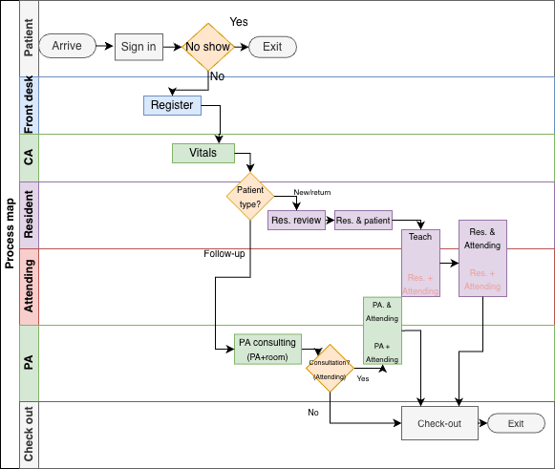

A decision point for no-show patients is modelled after Sign In, with a 10% probability of exit. This reflects the case description that 10% of scheduled appointments are cancelled, and that the clinic learns of these cancellations too late to fill the slot, meaning the appointment time is lost but no service is used. Arrivals are not modelled as a stochastic process, instead patients are generated according to the fixed schedule template shown in Table 6 of the case (Chambers & Williams, 2017, Table 6).

Modelling assumptions
Several simplifying assumptions are made to make the model manageable. First, Sign in is modelled as instantaneous, as it represents a time stamp event rather than a service activity consuming staff time. Second, the three residents are modelled as a shared resource pool with capacity 3 rather than as individually tracked agents. The patient entity seizes a resident from the pool at Resident Review and holds the resource through the entire sequence until Resident and Attending is complete. This reflects the case description that each resident follows a single patient through the full interaction. Third, teaching time variability across attending physicians is not modelled explicitly, a single fitted distribution is used for the Teach step representing an average across physicians. Fourth, the PA examination room is modeled as a separate resource from the three rooms used for New and Return patients, and as consistent with the case we note that the PA’s room is not available for other types of visits.

Mapping to JaamSim
The mapping from conceptual components to JaamSim implementation is summarized in Table 2 found in the appendix. Each activity is implemented as Server object. Routing decisions are implemented as Branch objects. A Queue object precedes each Server, with first in first out priority discipline. Routing decisions are implemented as Branch objects, and deterministic appointment arrivals are implemented using an EventSchedule object linked to an EntityGenerator. Patients who do not show up exit through an EntitySink after the no-show branch, while patients completing Check-out exit through the same sink via a Statistic object that records total time in system.

Four resources are implemented as Resource objects. Resource acquisition and release are handled through Seize and release objects. For new and return patients, a resident and an exam room are seized before Resident Review and held through Resident and Attending is complete. The Attending is seized before Teach and released only after Resident and Attending, ensuring it cannot be simultaneously engaged in more than one activity, directly reflecting the bottleneck identified in section 3.1a. For Follow-up patients, the PA exam room is seized before the PA step, and the Attending is seized for only 50% of cases requiring a consultation.

Appendix

Figure 1: Flowchart
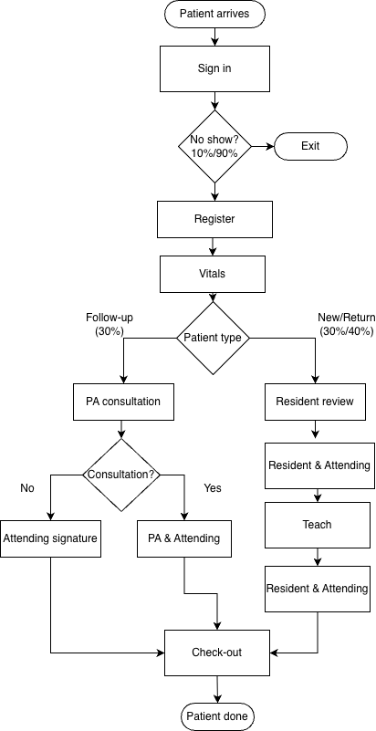

Table 2:
Components: | Simulation implementations: | Specifications & resources:
Arrival and routing:
Patient | SimEntity | One entity type. Patient type is decided by PatientType Branch
Scheduled arrivals | EntityGenerator, EventSchedule | 17 patients per schedule. Max number=17, Cycle time=10 h
No-show decision | Branch | P(continue)=0.90 Registration  P(no-show) =0.10exit. Sign in is instantaneous
Patient type routing | Branch | P(new)=0.30, P(return)=0.40, P(follow-up) =0.30
PA consulation? | Branch | P(consultation) = 0.50  P(not) = 0.50
Common input flow:
Register | Server, Queue | Gamma: (mean=4.333min, shape = 3.069)
Vitals | Server, Queue | Weibull: Scale=3.982min, shape = 2.107
New and return flow:
Resident Review | Seize, Server, Queue | Seize resident and exam room before step begins. New: Gamma( Mean=10.4 min). Return: LogNormal(μ=1.737, σ=1.002)
Resident & Patient | Server, Queue | New: LogNormal(μ=2.857, σ=0.558), Return: Weibull(scale=14.665 min, shape=1.740). SeizeAttending
Teach | Seize, Server, Queue | SeizeAttendingResource  New: Gamma(mean=7.861min), Return: Weibull(scale=5.438min)
Resident & Attending | Server, Queue | New: Gamma(mean=12.450min), Return: LogNormal(μ=1.942, σ=0.738)  After completed: Release Attending, release exam room, release resident check-out
Follow-up flow:
PA | Seize, Server, Queue | Seize PA exam room. LogNormal(μ=2.968, σ=0.541)
PA & Attending | Seize, Server, Queue | Seize Attending. Constant service time is 3 min.  After completed: release Attending, release exam room Check-out
Departure flow and output:
Check-Out | Server, Queue | Gamma(mean=4.724 min, shape=2.320) PatientStatistics Exit
Output | Statistics, EntitySink | PatientStatistics collect total time per patient
Resources:
Attending | Resource | Capacity = 1, used by New, Return and Follow-up.
Residents | Resource | Capacity = 3. Held from Resident Review through Resident & Attending
Examination room (New/Return) | Resource | Capacity = 3. Held from Resident Review through Resident & Attending
PA examination room | Resource | Capacity = 1. Dedicated to Follow-Up. Held from PA through PA & Attending

Sources
Laguna, M., & Marklund, J. (2019). Business Process, Modeling, Simulation and Design. CRC Press.

Chambers, C. & Williams, K. (2017). Case – Miller Pain Treatment Center. INFORMS Transactions on Education, 17(3), 121-127. https://doi.org/10.1287/ited.2017.0176cs

